Jarryd Hagedorn-Hansen Gr 12

Union High school

CAT-UNLOCKING A RESILIENT FUTURE

# Abstract

In this PAT task I will be addressing the different ways people have implemented ICT and other tools in the TRAIDING sector and how it has enabled them to stay open and available for their customers during the Covid-19 Pandemic.

I will be addressing what different types of ICT devices and Technology that have been invented or that have been a help and a way of life improvement in how we do things in the workplace, home and everyday lives.

I will be discussing these topics and going through the details of the PAT task after doing my research on Google and then creating a website to display all of my findings.

# Table of Contents

Contents

Table of Contents 1

Table of Figures 1

Introduction 2

Task Definition 3

What is the current situation? 3

What will be the focus and purpose of my investigation? 3

How will I go about the investigation considering all the PAT requirements? 3

Who is the target audience? 3

Focus Question 4

Discussion and Analysis 5

Findings 6

Conclusion 6

Bibliography 8

Appendices 9

Addendum A 9

Addendum B – Questions and sources table 0

# Table of Figures

Figure 1 5

Figure 2 5

Figure 3 5

Figure 4 8

Figure 5 8

Figure 6 8

Figure 7 8

Figure 8 0

Figure 9 0

Figure 10 1

Figure 11 1

Figure 12 2

Figure 13 0

# Introduction

In this investigation we will be exploring the impact of ICT on the Trading sector. Covid-19 and the lockdowns that came soon after affected the Trading sector greatly, with the virus taking control of the world during 2020 people found it very difficult to get to and from work, companies lost lots of money because no one came to support them and a lot of them closed down, throughout this PAT I will identify how with the help of Information Communication Technology (ICT) did these business stayed open and what are the differences between them and those who weren't so lucky.

# Task Definition

## What is the current situation?

In the end of 2019 the Covid-19 virus came in to the world and caused everyone unimaginable panic, by March of 2020 most of the world had gone into lockdown where no one was able to leave their homes, people couldn’t go to school, businesses closed down, people lost their jobs and no one knew what to do.

## What will be the focus and purpose of my investigation?

In this investigation I will be discussing the TRAIDING sector and how we as a country and how the rest of the world got through the world wide pandemic with all of the new innovations that would not of happened if the Covid-19 virus did not happen.  
 This PAT will focus on the different types of innovations that were created on an international level and the outcome of Covid-19.

## How will I go about the investigation considering all the PAT requirements?

I will do research on the internet, take surveys from family and friends that can assist me in the task, I will capture my findings and data in Excel, Access and other forms throughout the PAT task and I will present my findings in Report and websites.

# Who is the target audience?

My target audience for this PAT task are Head of companies that have been through the virus and those who are struggling with staying open and need the information on how to do such.

# 

# Focus Question

How has the Covid-19 virus changed the trading sector of the world and what are the outcomes that it has brought this Sector on an international scale.

# Discussion and Analysis

In the Servey of 25 People, this graph shows us what type of social platform they used during the lockdown period in order to keep inContact with work, friends or family. We can see that most people used zoom in this case.

When working from home online it is crucial to have a Woking internet connection, in this graph we can see that most people have internet, only 6 out of the 25 people might have struggled last year when going online.

People who have a deeper understanding of ICT have a higher chance in succeeding in the future, 14 people know what ICT is where only 6 of the 25 don't know what's happening.

# Findings

Figure 1 What type of applications were used.

From the results gathered by the survey most people understand ICT but the problem is implementing that knowledge and using it to your advantage.

When working in the trading sector it is difficult to know what your clients want or need, let alone deal with a pandemic so the goal in this PAT was to find out what is the difference in companies that closed down and companies that are open, I found that the main reason to this is that for one it needs to be a company that has goods, can't be a restaurant or a place for services, people need to be able to buy/support you without leaving their home.

To do this you need to be online, delivery to the customers doors by robot or drone and to implement a solid connection with clients.

# Conclusion

Figure 2 How many people understand ICT

Figure 3 how stable connections are for people who use ICT

# Bibliography

[Impact of covid-19 on Information, Communication & Technology Industry (fortunebusinessinsights.com)](https://www.fortunebusinessinsights.com/impact-of-covid-19-on-information-communication-and-technology-ict-industry-102769)

<https://www.bbc.com/future/article/20200629-which-lockdown-changes-are-here-to-stay>

<https://ictbyte.com/technology/ict-trends-in-2020/>

[27 Best Virtual Meeting Platforms for your Business in 2021 (techfunnel.com)](https://www.techfunnel.com/information-technology/11-best-virtual-meeting-platforms-for-business/)

[A Pandemic of Notifications: Major Challenges for Businesses During Lockdown (thequint.com)](https://www.thequint.com/voices/opinion/pandemic-of-notifications-challenges-for-businesses-during-covid-19-lockdown)

[How Much Covid-19 Cost Those Businesses That Stayed Open - WSJ](https://www.wsj.com/articles/how-much-covid-19-cost-those-businesses-that-stayed-open-11592910575)

[The impact of COVID-19 on small business outcomes and expectations | PNAS](https://www.pnas.org/content/117/30/17656)

# Appendices

# Addendum A

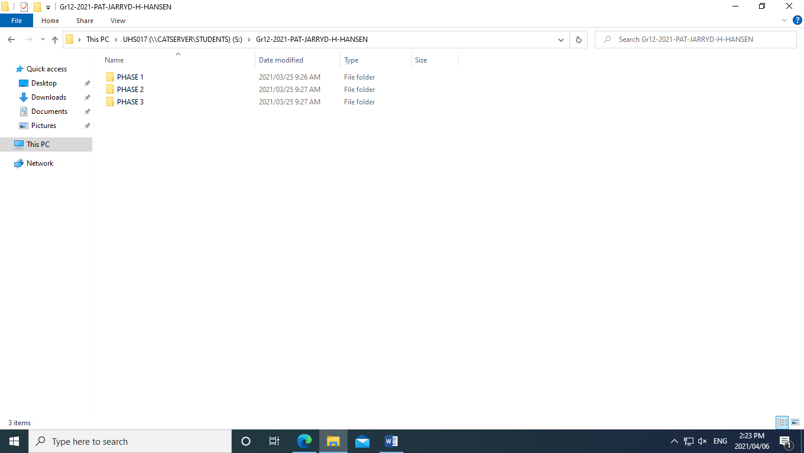

Figure 4

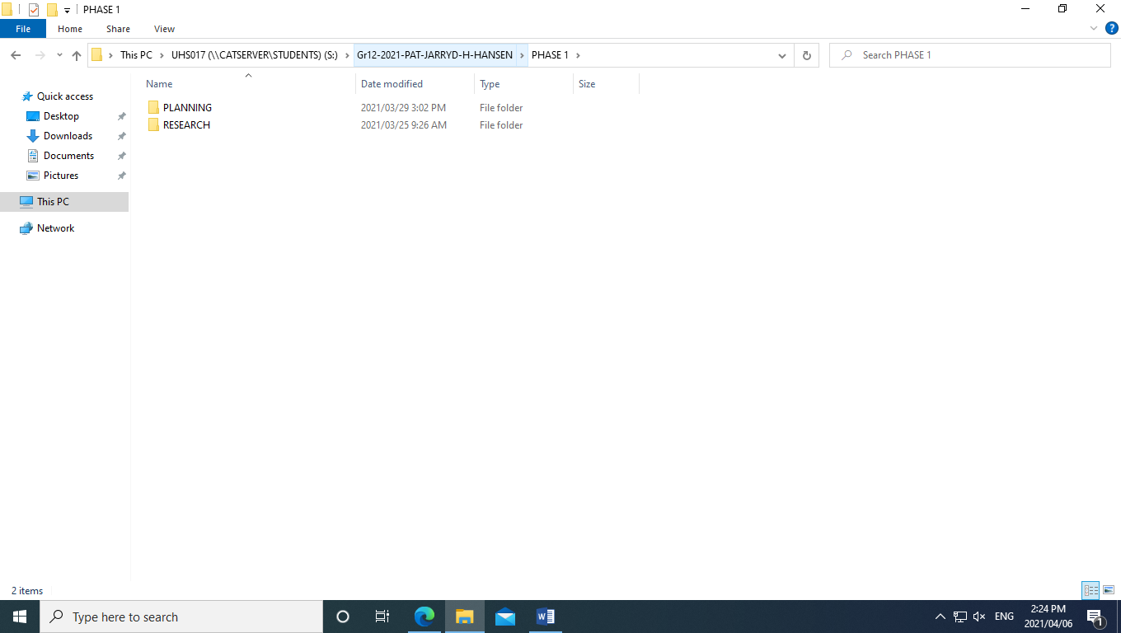

Figure 5

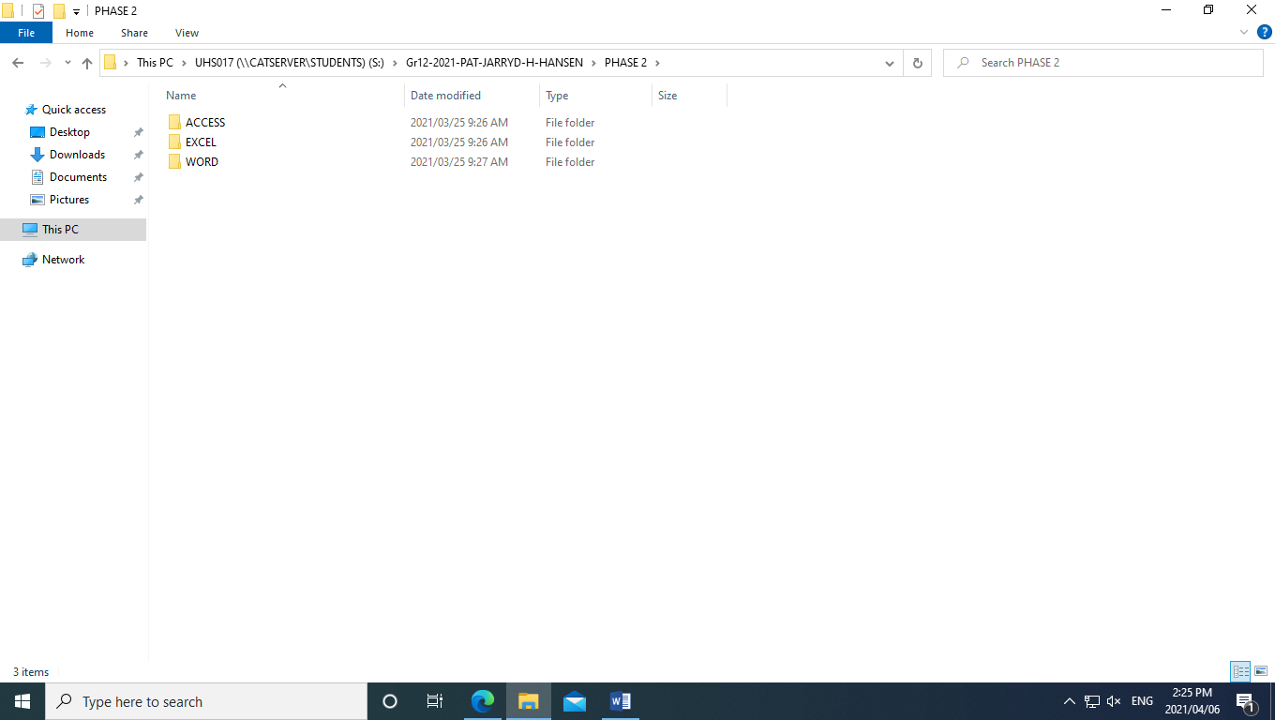

Figure 6

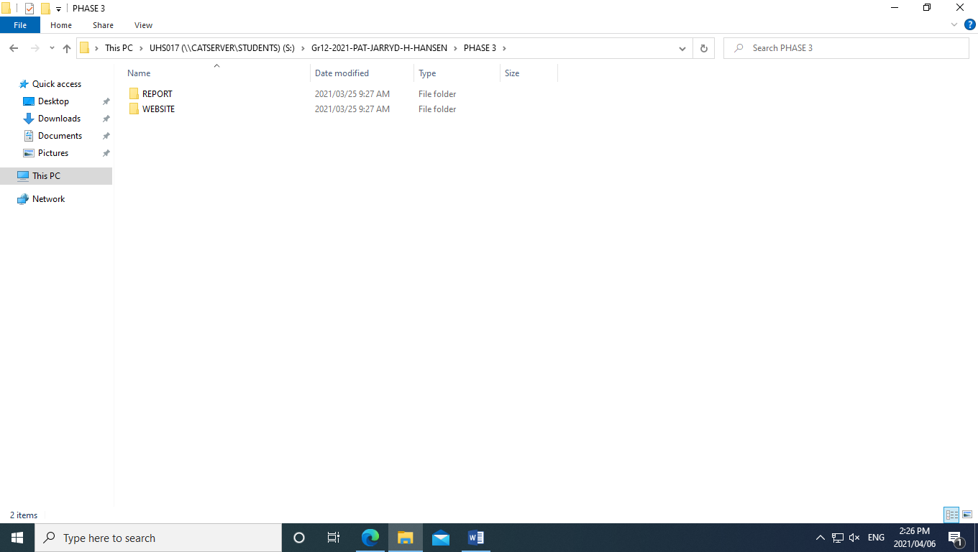

Figure 7

# Addendum B – Questions and sources table

|  |  |  |  |  |
| --- | --- | --- | --- | --- |
| **Category: Background** | | | | |
| **Nr** | **Question** | **Question Level** | **Type of source** | **Summary** |
| 1 | What online solutions were available for companies around the world? | 1 | Website | Source 1 |
| 2 | What did companies do to stay open during the lockdown period? | 1 | Website | Source 1 |
| 3 | Which companies thrived during this pandemic and which didn’t, what are the differences? | 2 | Own Opinion | Source 1 |

Figure 8

|  |  |  |  |  |
| --- | --- | --- | --- | --- |
| **Category: Impact** | | | | |
| **Nr** | **Question** | **Question Level** | **Type of source** | **Summary** |
| 4 | Will these online solutions help these companies in the long run? | 2 | Own Opinion | Source 1 |
| 5 | What if the companies could not adapt to the change of the lockdown period? | 1 | Own Opinion | Source 1 |
| 6 | What was the similarities between all the companies in the 2020-2021 period? | 1 | Stats | Source 2 |
| 7 | What was the biggest threat/difficulty that the companies experienced? | 1 | Website | Source 2 |
| **Category: Costs** | | | | |
| **Nr** | **Question** | **Question Level** | **Type of source** | **Summary** |
| 8 | What did it cost to keep these companies open and online during this period? | 1 | Website | Source 2 |
| 9 | Is it worth making the changes to the way the company operates/do the companies make a profit or loss? | 3 | Website | Source 2 |
| 10 | What is the Biggest cost for these companies? | 1 | Website | Source 2 |

Figure 9

|  |  |  |  |
| --- | --- | --- | --- |
| **Website source 1** | | | |
| **Bibliographical Information** | | **Quality of information found** | |
| Authors /  Organisations / Publisher | By Lewis Dartnell | Authority | The website is from BBC future where it was written by Lewis Dartnell, A professor at a University. |
| Name of website and webpage | The Covid-19 changes that could last long-term | Currency | It is very current, the page was updated in June 2020 |
| Date created/updated | 30 June 2020 | Accuracy | This website is helpful for my research, has a lot of Information. |
| Date accessed | 6th April 2021 | Objectivity | The website was written with the view and understanding of ICT. |
| URL | [The Covid-19 changes that could last long-term - BBC Future](https://www.bbc.com/future/article/20200629-which-lockdown-changes-are-here-to-stay) | Coverage |  |

Figure 10

|  |  |  |  |
| --- | --- | --- | --- |
| **Website source 1** | | | |
| **Bibliographical Information** | | **Quality of information found** | |
| Authors /  Organisations / Publisher |  | Authority | Reliable Source, Top level website with lots of information of ICT and business |
| Name of website and webpage | Fortune Business insights | Currency | Published in 2020 so it is relevant to my research |
| Date created/updated | May 2020 | Accuracy | The Website has information that is relevant to my questions. |
| Date accessed | 20 April 2021 | Objectivity | Non Bias, Made by high level business members that know what to do with ICT. |
| URL | [Impact of covid-19 on Information, Communication & Technology Industry (fortunebusinessinsights.com)](https://www.fortunebusinessinsights.com/impact-of-covid-19-on-information-communication-and-technology-ict-industry-102769) | Coverage |  |

Figure 11

|  |  |  |  |
| --- | --- | --- | --- |
| **Magazine source 3** | | | |
| **Bibliographical Information** | | **Quality of information found** | |
| Authors |  | Authority |  |
| Title of source | ICT Update | Currency |  |
| Date published/issued |  | Accuracy |  |
| Publisher |  | Objectivity |  |
| Coverage |  |

Figure 12

|  |  |  |  |  |
| --- | --- | --- | --- | --- |
| **Learner name** | Jarryd H – Hansen | | **ID Number** | 0307225277085 |
| **Grade** | 12 | | **Year** | 2021 |
| **Subject** | Computer Applications Technology | | | |
| Practical Assessment Task (PAT) | | | **Teacher** | Ms Jones |
| Did you receive any help/information from anyone to complete this project?  No RYes (provide details below) | | | | |
| Help/Information received from (person): | | Nature of the help/information (provide evidence): | | |
|  | |  | | |
| I hereby declare that the contents of this assessment task are my own original work (except where there is clear acknowledgement and appropriate reference to the work of others) and that I have not plagiarised, copied from someone else or used work previously submitted for assessment by anyone.    JHH  _________________________ 21/09/2021  SIGNATURE OF LEARNER DATE | | | | |

Figure 13